**EJS [EMBEDDED JAVA SCRIPT TEMPLATES]**

Link: ejs.co

Documentation: <https://github.com/mde/ejs/wiki/Using-EJS-with-Express>

|  |  |
| --- | --- |
| **REFRESHER** | |
| Framework | A framework is usually a library or some other piece of software that provides a skeleton for your application. It provides generic things that almost all applications need.  A programming language tells the computer what it should do. Every programming language features a syntax and a particular set of rules, which need to be followed every time the code is written.  A software framework is built on top of a programming language.  <https://hackr.io/blog/what-is-frameworks> |
| JavaScript | * Programming language * Allows you to make Websites interactive and engages with the user |
| NodeJS | * Back-end JavaScript **platform and environment (and not a framework)** * A platform that allows JavaScript to be executed outside of the web browser * It is not a framework but only a runtime environment to run JavaScript on server-side. * NodeJS, as a package, contains an interpreter and a compiler. |
| Express | * Web framework written in JavaScript and hosted by NodeJS. |
| EJS | * Is a **templating** engine used by NodeJS   You define HTML pages in the EJS syntax and you specify where various data will go in the page. Then, your app combines data with the template and "renders" a complete HTML page where EJS takes your data and inserts it into the web page according to how you've defined the template.  <https://stackoverflow.com/questions/64144316/what-is-ejs-what-is-the-use-of-ejs> |

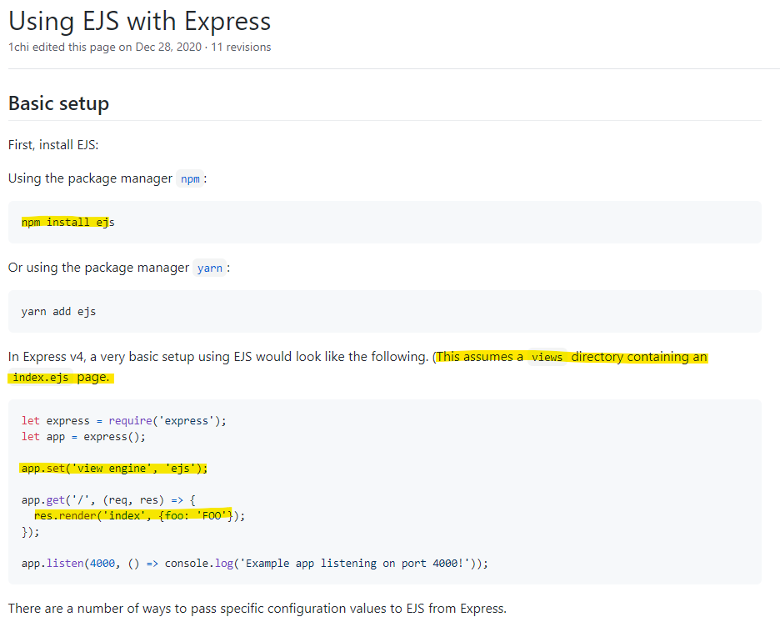

Source: <https://stackoverflow.com/questions/3552461/how-to-format-a-javascript-date>

If you need slightly less control over formatting than the currently accepted answer, Date#toLocaleDateString can be used to create standard locale-specific renderings. The locale and options arguments let applications specify the language whose formatting conventions should be used, and allow some customization of the rendering.

Options key examples:

day:

The representation of the day.

Possible values are "numeric", "2-digit".

weekday:

The representation of the weekday.

Possible values are "narrow", "short", "long".

year:

The representation of the year.

Possible values are "numeric", "2-digit".

month:

The representation of the month.

Possible values are "numeric", "2-digit", "narrow", "short", "long".

hour:

The representation of the hour.

Possible values are "numeric", "2-digit".

minute: The representation of the minute.

Possible values are "numeric", "2-digit".

second:

The representation of the second.

Possible values are "numeric", 2-digit".

All these keys are optional. You can change the number of options values based on your requirements, and this will also reflect the presence of each date time term.

Note: If you would only like to configure the content options, but still use the current locale, passing null for the first parameter will cause an error. Use undefined instead.

For different languages:

"en-US": For English

"hi-IN": For Hindi

"ja-JP": For Japanese